MAGIC vs AutoScore
Architecture & Instruction Comparison
LLaMA 3.1:8b + Gemma3:12b · 100 Essays · ASAP Dataset
Nikhil Yadav , Shamna Fathima

1. Runs Compared
Runs 1–3 used LLaMA 3.1:8b on 100 ASAP essays via local Ollama. Run 4 used Gemma3:12b on the same 100 essays (9 excluded due to JSON parse failures).

# | Run | Model | Pipeline | Instructions | Valid | QWK | r | MAE | Exact | ±1
1 | MAGIC 5-Agent GRE | LLaMA 3.1:8b | MAGIC | Original | 100/100 | 0.396 | 0.454 | 0.820 | 44.0% | 77.0%
2 | AutoScore 2-Agent ASAP | LLaMA 3.1:8b | AutoScore | Original | 100/100 | 0.410 | 0.546 | 0.747 | 44.4% | 82.8%
3 | MAGIC 5-Agent GRE | LLaMA 3.1:8b | MAGIC | Strict Calibration | 100/100 | 0.351 | 0.394 | 0.910 | 37.0% | 78.0%
4 | AutoScore 2-Agent ASAP | Gemma3:12b | AutoScore | Original | 91/100 | 0.273 | 0.404 | 0.934 | 33.0% | 75.8%

2. Strict Calibration Instructions (Run 3)
Run 3 used modified prompts with explicit calibration instructions added to all 3 agent system prompts and the orchestrator prompt. The goal was to reduce LLM leniency bias — the tendency to avoid giving low scores (0/1/2) and suppress high scores (5/6).

Added to each agent prompt:

IMPORTANT CALIBRATION INSTRUCTIONS:
- These are student essays (grade 7-10 level). Score relative to student writing
standards, NOT graduate-level expectations.
- You MUST use the full scoring range 0-6. In a typical student dataset:
scores 0-2 apply to roughly 20% of essays, scores 3-4 to roughly 50%,
scores 5-6 to roughly 30%.
- SCORE 5-6 (HIGH): Award when the essay is genuinely strong FOR STUDENT LEVEL.
A well-written student essay SHOULD receive 5 or 6. Do NOT reserve these for perfection.
- SCORE 3-4 (MID): Average student work — some development but with clear weaknesses.
- SCORE 0-2 (LOW): Clearly weak — blank, off-topic, incoherent, extremely brief.
Do NOT avoid low scores out of politeness.
- Inflating weak essays AND suppressing strong ones are equally harmful.

Additionally added to orchestrator prompt:

- If multiple expert graders assign low scores (1-2), your holistic score MUST
reflect that — do NOT inflate to 3.
- If expert graders mostly assign 4-5, your holistic score SHOULD be 5 or 6.
Do NOT suppress high scores out of caution.

Why this approach was chosen:

- LLMs are trained via RLHF to be encouraging and avoid being 'harsh' — this causes systematic score inflation at the low end and suppression at the high end.
- Adding explicit score distribution targets (20%/50%/30%) gives the model a concrete calibration reference.
- Symmetric anchors for BOTH extremes prevent overcorrection in either direction.
- The orchestrator-level rule prevents agent-level inflation from being compounded during synthesis.

3. Metric-by-Metric Comparison

QWK — Primary Metric (Agreement with Human)
Run | QWK | Band
MAGIC Original | 0.396 | Fair
AutoScore | 0.410 ✓ Best | Moderate
MAGIC Strict | 0.351 | Fair

AutoScore leads. Strict instructions hurt MAGIC — QWK dropped by 0.045. The model overcorrected on the low end, pushing mid-range essays (human score 3) down to 2.
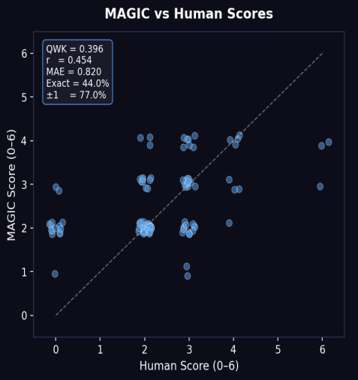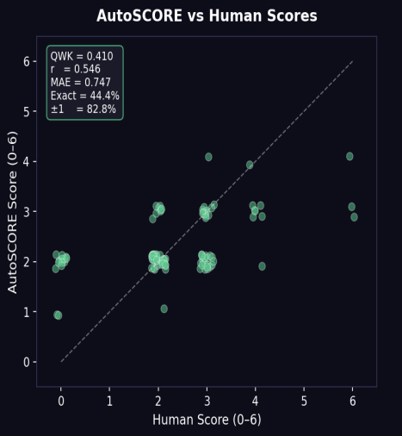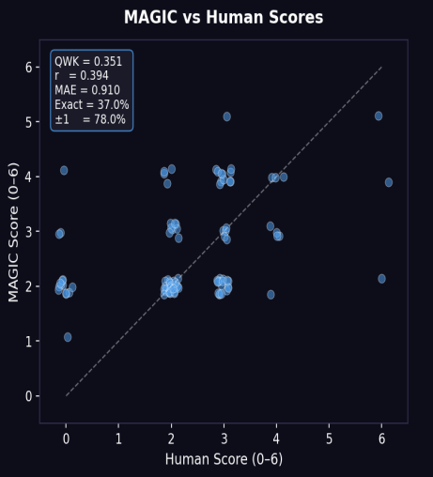
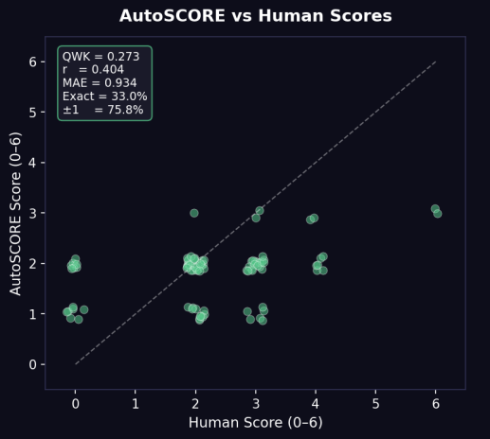

MAE — Average Grade-Point Error
Run | MAE | Interpretation
MAGIC Original | 0.820 | Less than 1 grade off
AutoScore | 0.747 ✓ Best | Closest to human
MAGIC Strict | 0.910 | Slightly over 1 grade off

±1% — Industry Standard Threshold
Run | ±1%
MAGIC Original | 77.0%
AutoScore | 82.8% ✓ Best
MAGIC Strict | 78.0%

AutoScore wins. 83% of scores within 1 grade of human — comfortably above the 80% industry benchmark.

Exact Match %
Run | Exact %
MAGIC Original | 44.0%
AutoScore | 44.4% ✓ Best
MAGIC Strict | 37.0%

4. Confusion Matrix Analysis

Run 1 — MAGIC Original
Image placeholder below — insert the MAGIC Original confusion matrix heatmap here.

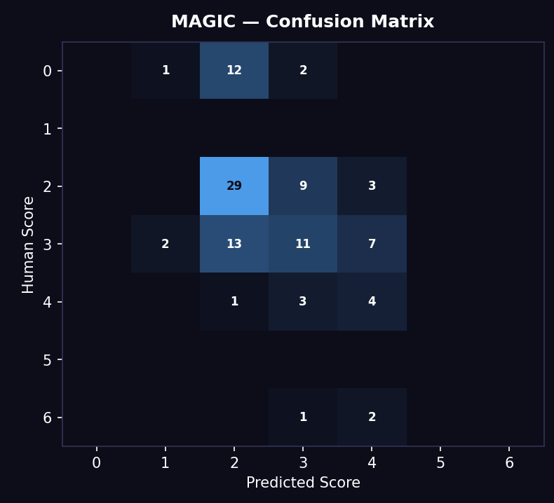

Key observations:
- Human 0 essays → predicted as 2, 3, and 4. Severe over-scoring — weakest essays pushed up to 4.
- Human 2 essays → predicted mostly as 4. Massive over-scoring — dominant cell is 4, not 2.
- Human 3 essays → predicted as 4-5. Strong upward push.
- Score 0, 1, and 2 are essentially never predicted — the model refuses to assign low scores.
- Pattern: Strong positive/leniency bias — predictions cluster at 4-5 regardless of true score.

Run 2 — AutoScore
Image placeholder below — insert the AutoScore confusion matrix heatmap here.

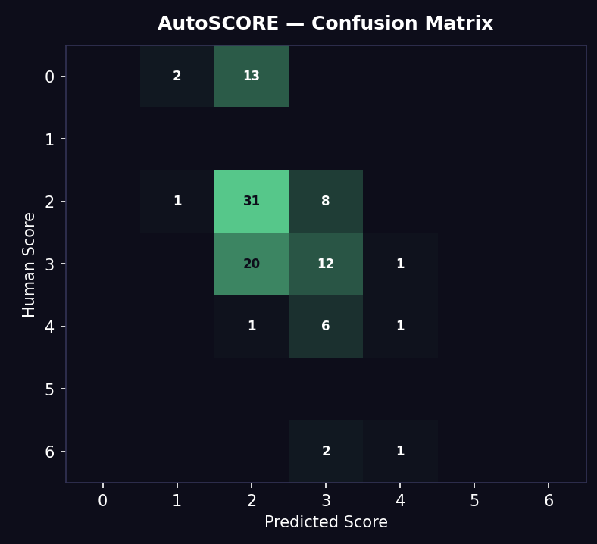

Key observations:
- Human 0 essays → predicted as 1 and 2. Less severe than MAGIC.
- Human 2 essays → 31 correct at 2 — strongest diagonal cell across all 3 runs.
- Human 3 essays → mild under-scoring, 12 correct.
- Score 0, 5, and 6 are never predicted — model compresses into the 1-4 band.
- Pattern: Conservative and consistent — tight clustering around 2-3, strongest on low-mid range, weak at high end.

Run 3 — MAGIC Strict Instructions
Image placeholder below — insert the MAGIC Strict confusion matrix heatmap here.

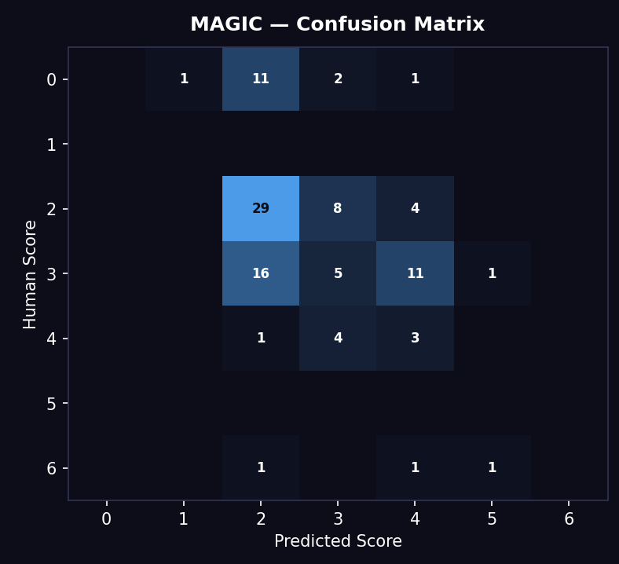

Key observations:
- Human 0 essays → predicted as 1-2 (improvement over Run 1, which pushed these to 4).
- Human 2 essays → 29 correct at 2 — big improvement over Run 1.
- Human 3 essays → overcorrection visible — 16 of 33 true-3 essays pushed down to 2.
- Pattern: Overcorrected downward — reduced high-end inflation but pushed many true-3 essays to 2.

5. Why Strict Instructions Lowered QWK on LLaMA 3.1:8b
The instructions were not a clean failure — they had a mixed effect.

What improved (intended effect):
- Run 1 pushed weak essays (Human 0-2) up to score 4. Run 3 correctly scored most down to 1-2.

What broke (unintended side effect):
- The model over-applied the 'give low scores' signal and pushed many true mid-range essays (Human 3) down to 2.
- Because QWK penalises distance quadratically, mass-shifting 3s down to 2s cost more than the gains from fixing 0-2 essays.

Why an 8b model reacts this way:
- Limited instruction-following capacity — picked up the strongest signal and applied it broadly without nuance.
- The distribution reminder was over-applied — nudged the model to assign low scores more liberally across the board.
- Asymmetric uptake — low-score guidance was acted on more strongly than high-score guidance.
- Instruction-based calibration scales with model size — larger models follow multi-constraint instructions more reliably.

Takeaway: The instruction approach is sound in principle but needs either (a) a larger model that can follow the nuance, or (b) softer wording that does not over-trigger the low-score response on an 8b model.

6. Which to Use — For What Purpose

Use AutoScore when:
- Raw accuracy is the priority — highest QWK, best MAE, best ±1%.
- The task is pass/fail or grade-assignment where a single accurate number matters.
- Working with a smaller model (≤8b parameters).
- Simpler, more interpretable pipeline is preferred.

Use MAGIC when:
- Rich, actionable feedback is the priority — 5 dimensional scores show WHERE points were lost.
- The end product is a student-facing tool (like EssayIQ) where per-dimension breakdown is valuable.
- A larger model is available (12b+) — MAGIC's multi-agent parallelism benefits more from model capability.
- Explainability for a professor, evaluator, or presentation is needed.

Core Tradeoff Summary
Dimension | AutoScore | MAGIC
Accuracy on 8b (QWK) | 0.410 ✓ Better | 0.396
Feedback depth | Single holistic score | 5-dimension breakdown ✓
Speed | Faster (2 sequential calls) | Slower (5 parallel + orchestrator)
Small-model (8b) fit | Better (confirmed) ✓ | Slightly behind
Large-model fit | Good | Hypothesised better*
Student usefulness | Low | High ✓
Research explainability | Low | High ✓

7. Key Research Finding
On a small model (LLaMA 3.1:8b), architecture and accuracy do not trade off cleanly against feedback richness. AutoScore's simpler, sequential two-agent design achieves the best agreement with human scores (QWK 0.410) — its step-by-step evidence-then-score structure keeps an 8b model grounded. MAGIC's five-agent parallel design is slightly less accurate (QWK 0.396) but produces a per-dimension breakdown that AutoScore cannot — making it more useful for a student-facing product even when the holistic number is marginally less precise.

The hypothesis that MAGIC's multi-agent design pulls ahead on larger models is plausible but not yet confirmed — the gemma3:12b MAGIC run (QWK 0.346) did not beat llama3.1:8b, so model family and quantisation matter as much as raw size. Confirming this requires testing MAGIC on a strong instruction-following model (Gemini 2.5 Pro / GPT-4o).

8. Run 4 — AutoScore + Gemma3:12b
QWK: 0.273 | r: 0.404 | MAE: 0.934 | Exact: 33.0% | ±1: 75.8% | Valid: 91/100

Overview
This run tested whether a larger model (Gemma3:12b) improves AutoScore's accuracy beyond LLaMA 3.1:8b (QWK 0.410). The result was the opposite — Gemma3:12b performed worse on every metric. This demonstrates that model size does not guarantee better performance in structured pipelines; instruction-following reliability matters more.

9 of 100 essays failed with a JSON parse error: Gemma3:12b wrapped its output in markdown code fences (```json ... ```) despite the scoring prompt explicitly instructing 'Output ONLY the JSON object — no preamble, no explanation, no markdown code fences'. LLaMA 3.1:8b had 0 such failures on the same pipeline.

Run 4 — Confusion Matrix
Image placeholder below — insert the Gemma3:12b AutoScore confusion matrix heatmap here.

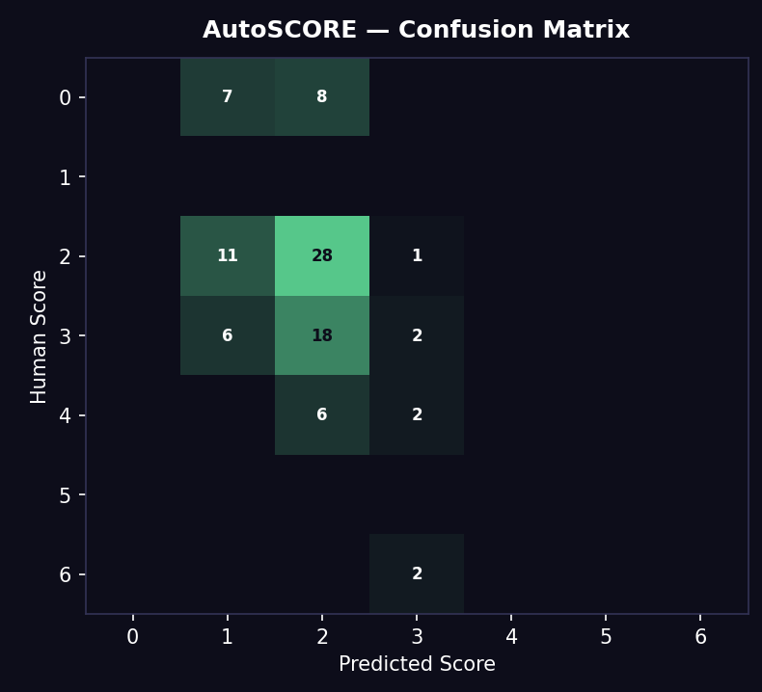

Key observations:
- Human 0 essays → predicted as 1 (7) and 2 (8). Never predicts 0 — low-end inflation present but score range is lower than MAGIC's 4-5.
- Human 2 essays → predicted as 1 (11), 2 (28), 3 (1). 28 correct — reasonable low-range accuracy but 11 under-scored to 1.
- Human 3 essays → predicted as 1 (6), 2 (18), 3 (2). Only 2 correct — severe under-scoring of mid-range, pulled to 1-2.
- Human 4 essays → predicted as 2 (6) and 3 (2). Never reaches 4 — high-end pulled down.
- Human 6 essays → predicted as 3 (2) only. High-end suppression.
- Scores 4, 5, 6 almost never predicted.
- Pattern: Strong under-scoring bias — predictions compressed into the 1-2 band. More conservative than LLaMA AutoScore which clustered at 2-3.

Why Gemma3:12b Underperforms LLaMA 3.1:8b on AutoScore
AutoScore's architecture depends on two strict JSON contracts:
- SRCE Agent must output a clean evidence JSON (no scores, no extra text).
- Scoring Agent must output a clean scoring JSON (no markdown, no preamble).

Gemma3:12b fails the second contract reliably — it adds markdown fences even when explicitly told not to. This produces 9% parse failures. The valid 91 essays are also affected: the model's tendency to add commentary around JSON suggests its internal representation is less strictly 'JSON-first,' which may degrade scoring quality even when parsing succeeds.

LLaMA 3.1:8b follows the JSON-only instruction faithfully (0 failures), making it more compatible with AutoScore's structured pipeline despite being a smaller model.

Key finding: AutoScore's accuracy depends on instruction-following precision, not raw model scale. A model that reliably follows the JSON contract outperforms a larger model that doesn't.

9. Cross-Run Comparison — All 4 Runs
Rank | Run | Model | QWK | Pattern
1 | AutoScore | LLaMA 3.1:8b | 0.410 ✓ Best | Conservative, strong low-mid range
2 | MAGIC Original | LLaMA 3.1:8b | 0.396 | Leniency bias, over-scores to 4-5
3 | MAGIC Strict | LLaMA 3.1:8b | 0.351 | Overcorrected, pushes 3s → 2s
4 | AutoScore | Gemma3:12b | 0.273 | Under-scoring bias, JSON failures

Key insight: LLaMA 3.1:8b is the best-performing model across both architectures. Its reliability on JSON contracts (AutoScore) and consistent scoring behaviour (MAGIC) outweigh Gemma3:12b's parameter advantage. This strongly suggests instruction-following accuracy is the primary quality driver for structured multi-agent pipelines, not model size.

